The World Has Got A Cough

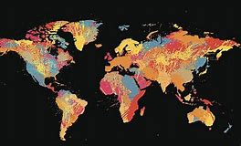

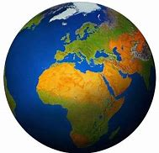
One day the world caught a cough. The cough started in a country far far away and lots of people started coughing. The germs in the cough started to travel around the world.

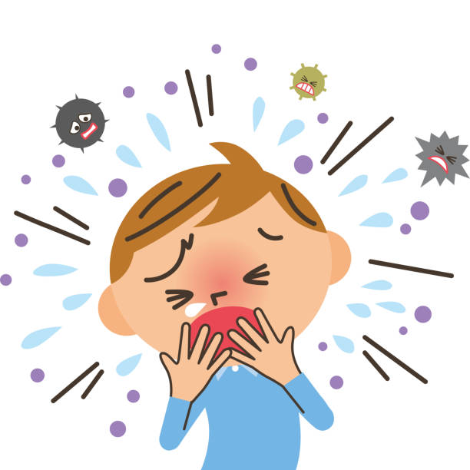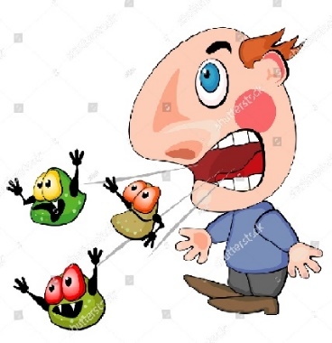

We live in a city called Bristol which is in our country called the United Kingdom. One day the cough germs arrived in Bristol.

To stop the cough germs from spreading to everyone in Bristol it was decided that we should all stay at home with our families.

This means that mummy and daddy will be at home a lot more. Older ( or insert siblings names) will not go to school and (insert the child’s name) will not go to (insert childcare providers name) to play. We may not see our grandparents as much as we would like to or play with our friends.
But remember there are so many fun things we can do at home together, what is your favourite game to play at home?

It’s really important we try to keep the cough germs away and we can do this by washing our hands with lots of soap. A grownup may help you to do this.

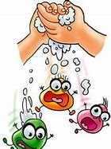

It may feel like quite a long time before we can play with our friends again, but we can talk to each other on the phone and tell them all about the fun we are having at home.

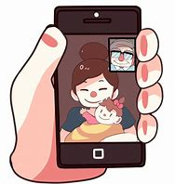

We can still go out for a walk with our family, we just need to remember to stand back from other people in case they have the cough germs because we can’t see the germs.

Children all around the world are also staying at home with their families. It may feel strange to be at home, you may miss your friends or grandparents, so remember to have a cuddle to help you feel better.

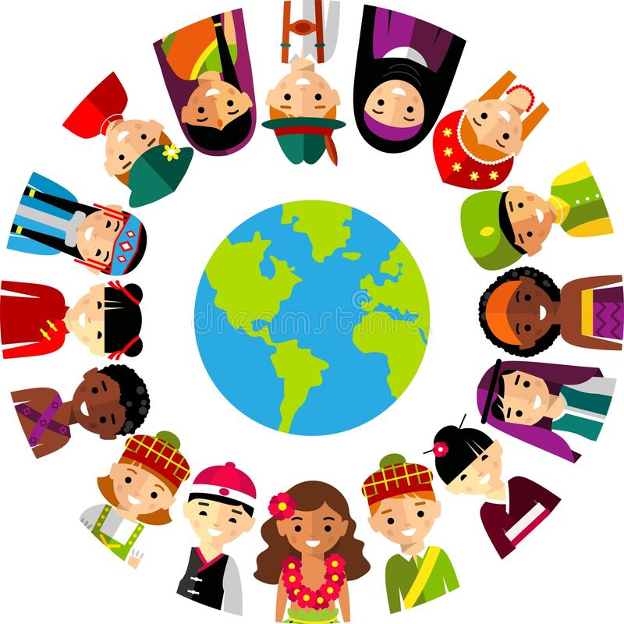

When the cough germs have gone, we really look forward to seeing all our friends and family again, and going back to Filton Avenue.

