Today is… | Who is looking after us?  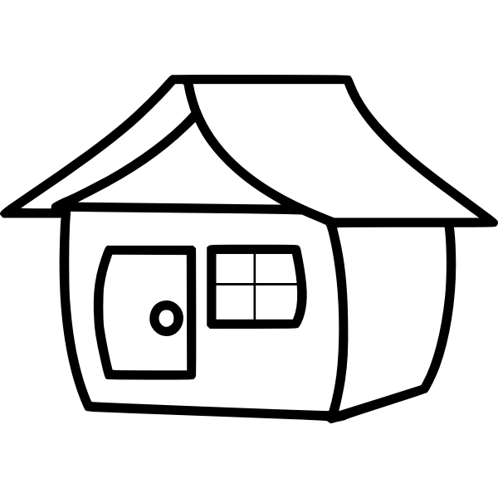 | Who is at work? | 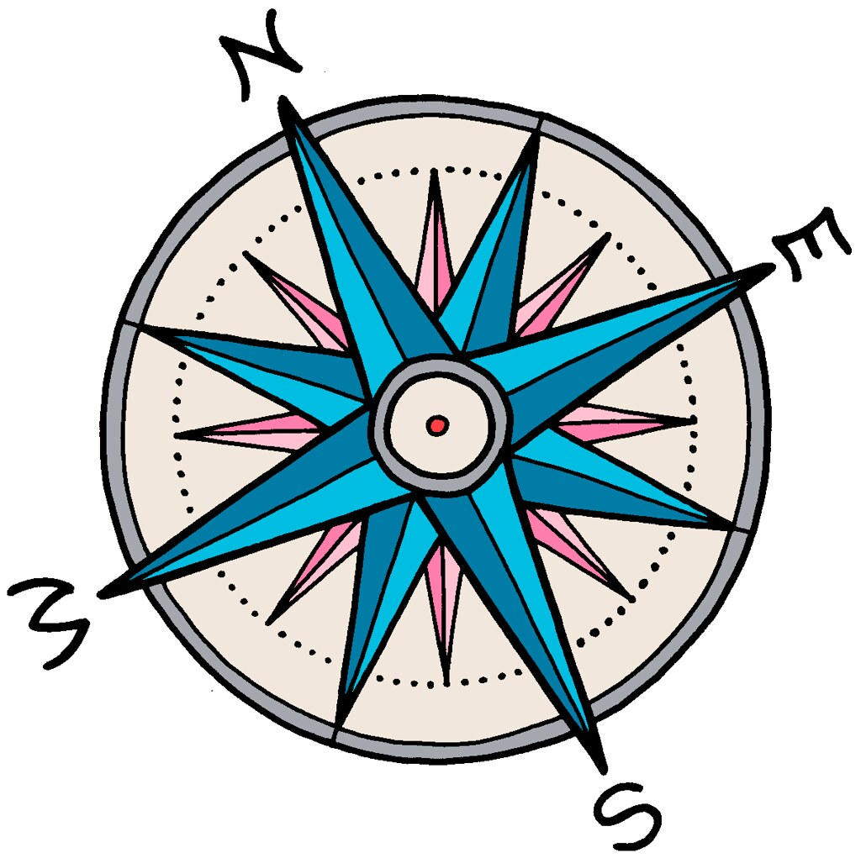  Where are we? | 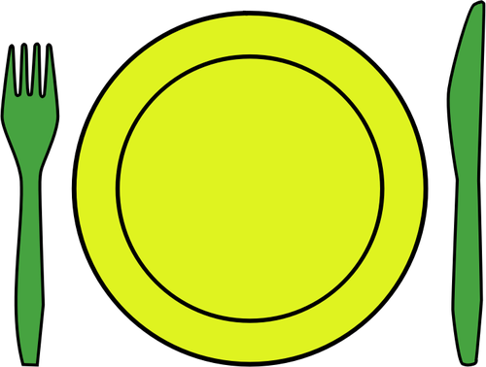  We will eat…
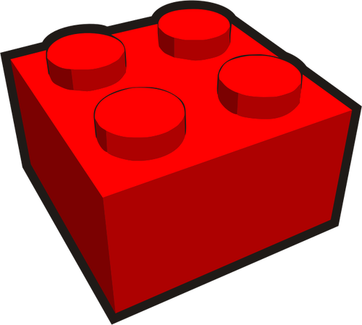  We will play… | We will make… | We will watch / play… | 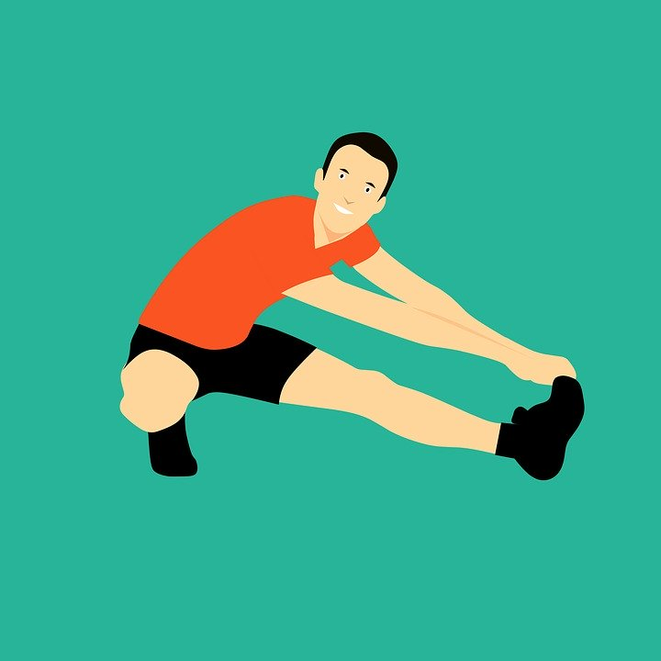  We will do…  (exercise) | 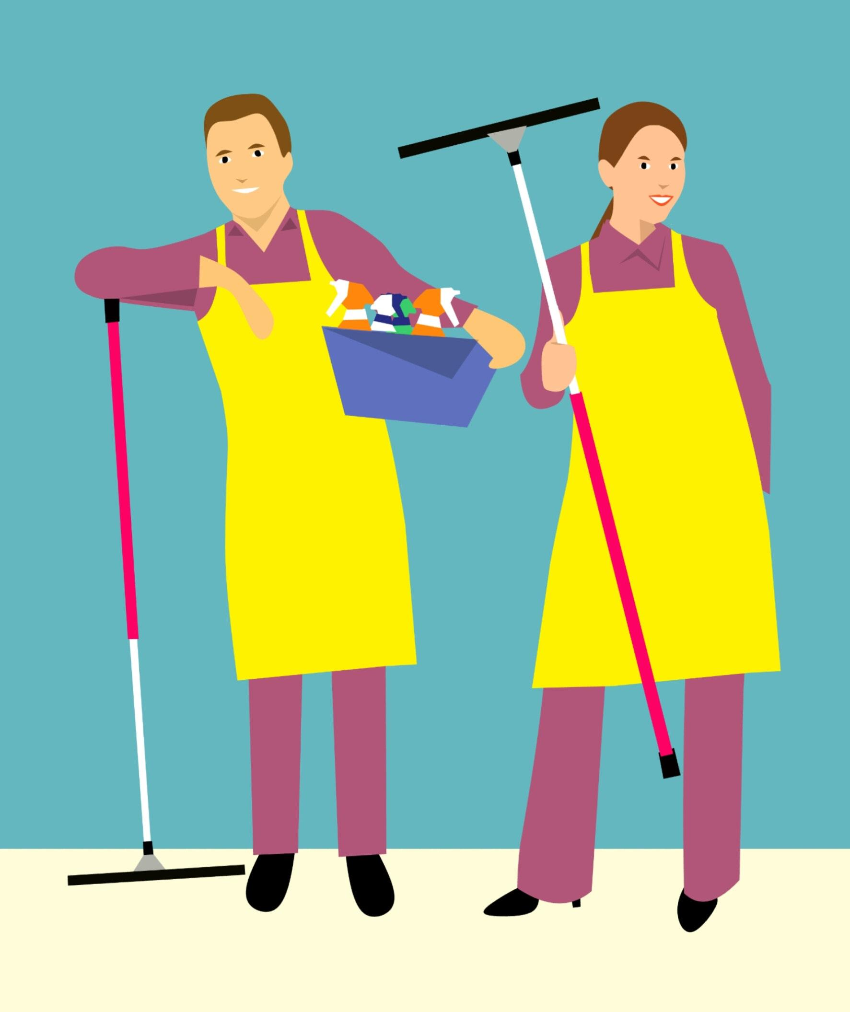  Jobs to do…

breakfast | snack | snack | lunch | dinner | play | play
make | make | exercise | watch / play | watch / play | play | play
make | make | exercise | watch / play | watch / play | play | play
jobs | jobs | jobs | exercise | relax / nap | change

Set up:
- Customise if needed (change images and words, add to blank squares)
- Print both pages (not double sided)
- If possible, laminate first page or put inside a plastic wallet
- Cut out small pictures and laminate if possible
- Either put sticky velcro on back of small pictures with long velcro strip on line at bottom of first page, or use blu tac
How to use:
- Spend time each morning looking at the first page together, writing down ideas of what you want to do that day.
  - If the page is laminated, you can use a whiteboard pen.
  - For example, we want to watch the Lego movie, we want to eat sandwiches, we want to play superheroes
- Put the small pictures on the line across the bottom, in the order you will do them
  - You might want to do part of the day e.g. up to lunchtime to avoid this being overwhelming
  - Use the change picture if something changes
  - Take pictures off when the task is completed
- Display somewhere visible and check back often

