Tips for parents of children with autism
for spending time at home over the Corona Virus outbreak
(from the Bristol Autism Team)

Introduction:

We have put together this resource in response to requests from families we know in Bristol about supporting children at home over this time of uncertainty.

Schools will provide support and information about learning at home should they close. This resource has some additional strategies relating to structuring time and planning for children with autism. There may be many other strategies that you have used in the past for your child and it could be a good time to think about bringing back strategies that have worked in the past in terms of structuring time and managing sensory and/or communication needs at home.

Of course, as always, take those bits that are helpful for you and your family and remember that at times of change trying to do too much that is new can be quite overwhelming for children with autism as well as their parents. Just choosing one or two things to introduce could be the best way forward initially along with planning and pacing for yourself as well.

Preparing for more time at home:

- It will be important to help children to understand the day and position in the week and try to maintain a weekly structure that mirrors your usual life where possible (e.g. working Monday to Friday during the day with clearer family time on the weekend).

- If you are all working at home then try to set up working areas and a structure to the day with clear times when you are available to spend time together (e.g. a tea break each day with Daddy). This will prevent the children’s anxiety growing about the change in parental routine and communicate to them that even though you are working at home, there are clear times in the day when you are fully available for them.

- Many children on the spectrum benefit hugely from visual planning and a visual structure. For younger children using a calendar like this will help them to keep perspective each day of where they are in the week or month:

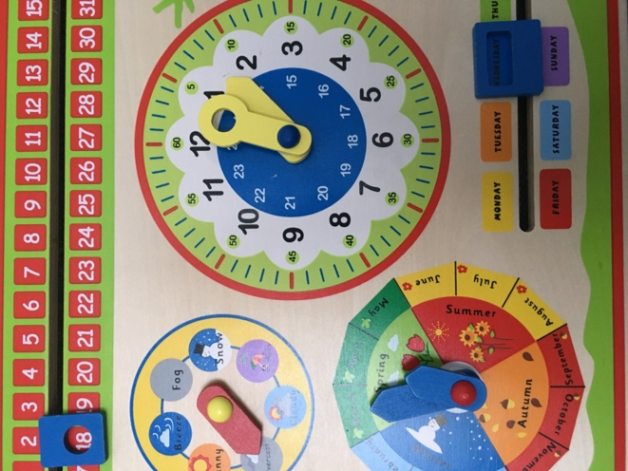

For older children having a wall chart and/or calendar where they can tick off the days will help.

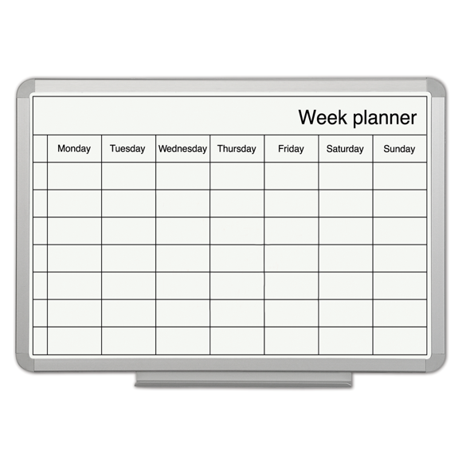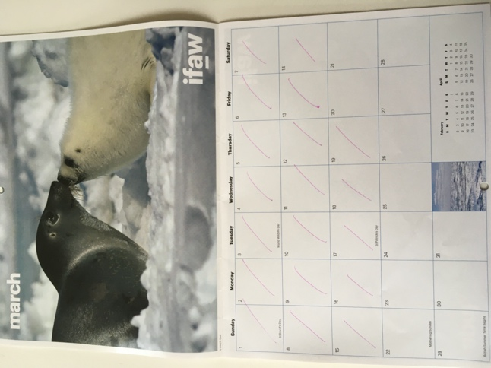

- Try to maintain a daily plan as well. White boards can be really helpful for structuring the day or small work tasks:

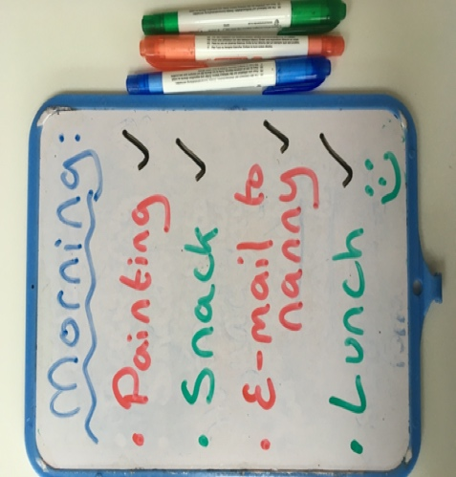
Some thoughts towards learning at home:

- Schools will give guidance for parents on completing work at home. However, some children on the spectrum may find learning from home particularly difficult given that this is a change in context and a change in your role towards them. It is important not to worry too much about this or put pressure on yourself or your child.

- Initially if you can spend some time building up some positive/reinforcing activities this could set the scene for spending a bit more time together. From this platform you may then be able to introduce some periods for completing some level of school work amongst other activities while they are at home.

  - It may help to think about sorting some activities at home in to different spaces or categories perhaps using colours or animals to grade them (an example of this might be, ‘cheetah activities’ for very fast/active games, ‘rabbit activities’ for slower paced games/work activities and ‘sloth activities’ for downtime (which might include TV or screen time). In supporting children at home, it will help to think about pacing their day to include the right mix for them.

  - Remember that sensory strategies and activity breaks could be crucial to include. Gather together a sensory/fiddle tool box if this isn’t already around at home. This can also be really helpful for supporting anxiety (not just in terms of fiddling but also sound and taste/sucking.

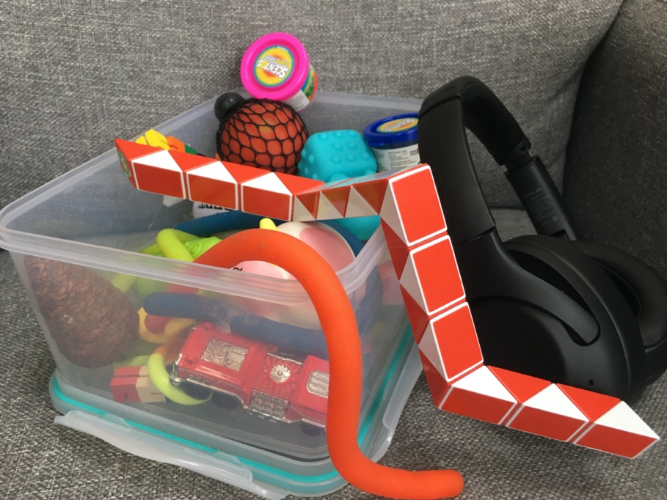

  - It may help to introduce some new work or colouring books which could help with engaging them:

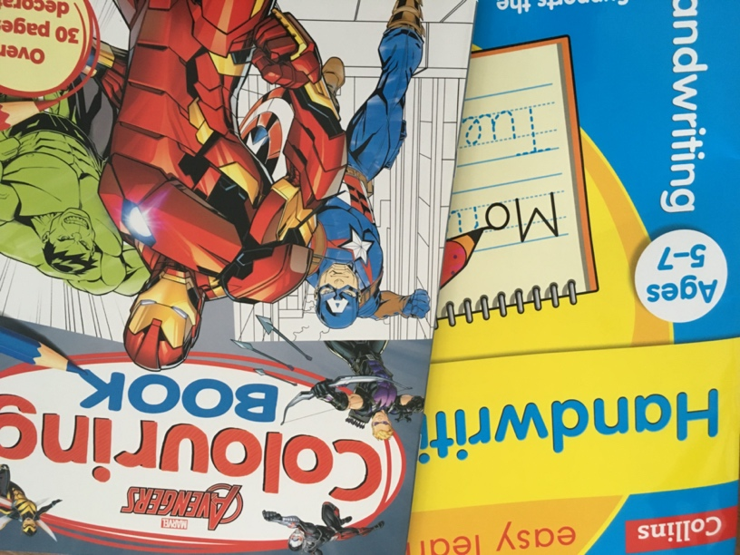

  - It might also help to have a think about some project learning that they might enjoy (although this may also come from school). Ideas might include learning about the Seasons (which will help them to stay grounded in their outdoor environment as well) or expanding on their own personal interests (e.g. to learn about the history of Lego or Minecraft). Any visual approach from scrap books to power points are a great way of helping your child gather together their ideas and target other skills at the same time.

  - Many children on the spectrum have a great flair for organisation and sorting. Have a think about any jobs/roles that your child could help with or take change of over this time.

This could be functional things like taking charge of the recycling or sorting out a cupboard:

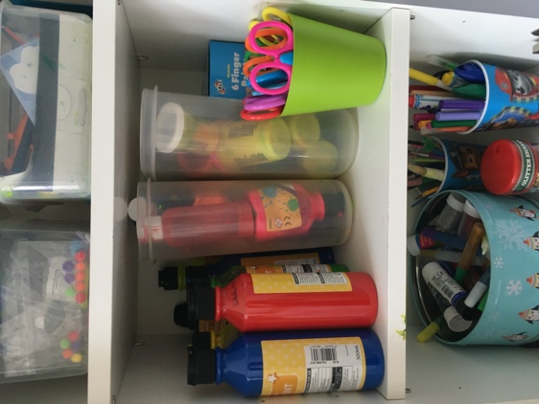

Or it could be just for fun like this lovely rainbow bookcase and Swedish flag:

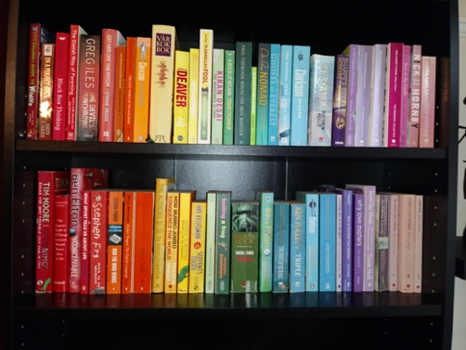

- There are some excellent resources already available from web-based support for home education:

  - www.twinkl.co.uk

- Staying connected with local Autism supports (e.g. on facebook groups) will also help with picking up further tips and resources.

Stay connected with friends and family:

- Help your children to stay in touch with their friends using an appropriate level of Skype or social media and stay connected with usual friends and family. Writing letters by hand (to send as a picture image) or using email could be a great way for your children to stay in touch with their school friends whilst targeting other skills too.

- For many children on the spectrum their favourite LSA or teacher can be very important to them. If schools close then prioritise a discussion with your child’s favourite key-worker/s to set up the boundaries around communication with them whilst the schools are off (for example, the frequency of Skype or written contact that might be possible during term time and providing they are well). This could help your child with the separation from school and can then be planned in to their day/week.

Be aware of screen time for you and your child:

- Watts app groups are a great way of staying in touch with friends and family but it will help as well as we move forwards to keep in mind that having a constant feed of others news and potential anxiety can also inflate our own.

- To help with this, advice suggests that having a time in the day to check in on wats app or other social media will help us to keep this in check.

- It is obvious to say, but it’s difficult for children to understand rules around screen time when parents are on their phones a lot as well. Have a think about fresh rules (for parents and children) over this time when everyone is at home and try to set boundaries early on for your children’s screen time each day and how this might fit in best (e.g. in one block or broken up through the day). If you can make this visual as well then it will help them in terms of getting through the day and planning in their other activities as well and keeping things positive (see example below).

A note on children who are avoidant and/or find fixed routines difficult:

- It may help for these children to have a more flexible daily structure that you agree each day.

- Keeping in mind the negotiables and non-negotiables of each day could help with this planning. Also think about some of the non-negotiables that may be included from your child’s perspective and how to keep these at a reasonable level (for example, in terms of computer/screen time).

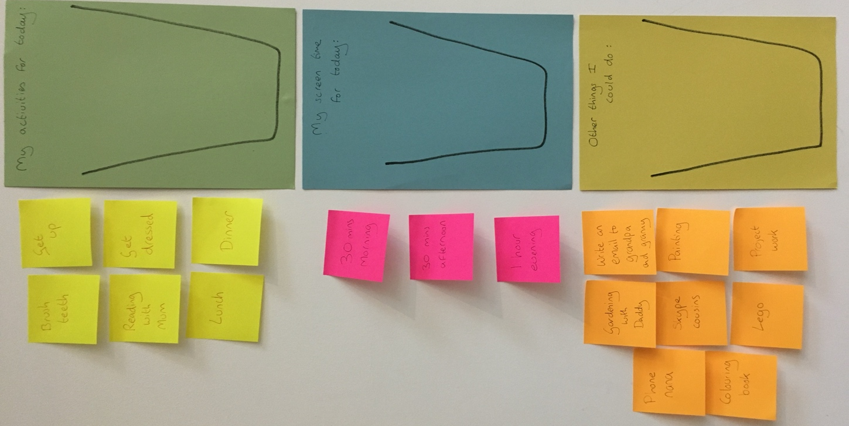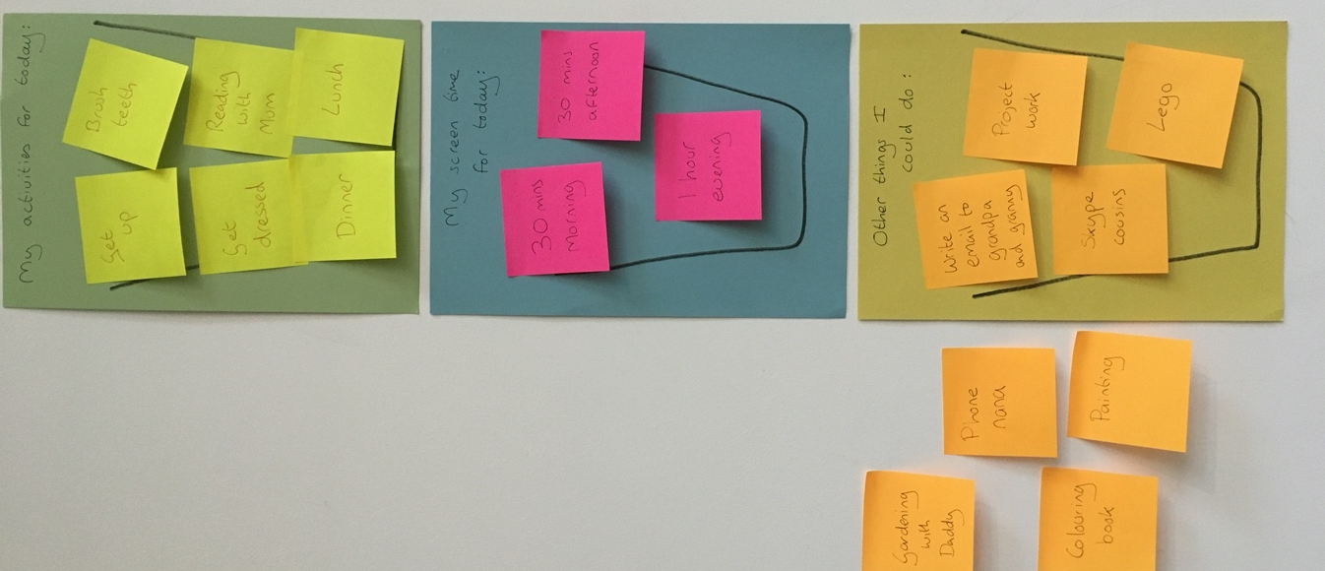

If visuals increase anxiety for your child then just talking through each day in this way could help to set things up for them and give ideas for further activities on days when they are more motivated.

Here are some further links relating to Corona Virus advice:

American Psychological Association: Information on Pandemics (a wide range of resources)
https://www.apa.org/practice/programs/dmhi/research-information/pandemics?utm_source=linkedin&utm_medium=social&utm_campaign=apa-pandemics&utm_content=pandemics-resources

Anna Freud: Self-Care and Coping Strategies
https://www.annafreud.org/selfcare/

BBC: How to protect your mental health
https://www.bbc.co.uk/news/health-51873799
CBBC: Video and Questions
https://www.bbc.co.uk/newsround/51861089
ChildMind: Talking to Children
https://childmind.org/article/talking-to-kids-about-the-coronavirus/
ELSA: Coronavirus Story for Children
https://www.elsa-support.co.uk/coronavirus-story-for-children/
National Association of School Psychologists: Parent Resources
https://www.nasponline.org/resources-and-publications/resources-and-podcasts/school-climate-safety-and-crisis/health-crisis-resources/talking-to-children-about-covid-19-(coronavirus)-a-parent-resource
Young Minds: Feeling Anxious about Coronavirus
https://youngminds.org.uk/blog/what-to-do-if-you-re-anxious-about-coronavirus

This website provides a further helpful overview of advice and resources:
https://edpsy.org.uk/blog/2020/coronavirus-covid-19-information-for-children-families-and-professionals/

Here are some books which may be helpful in explaining things and/or to help with talking about feelings:

Something Bad Happened: A Kid’s Guide to Coping with events in the News
Dawn Huebner. How to process different world events (ages 6-12).
The Day the Sea Went Out and Never Came Back
Margot Sunderland. A story for children who have lost someone they love (ages 4-12).
Draw on Your Emotions
Margot Sunderland. A resource to help people express and communication their emotions.
What To Do When You’re Scared & Worried: A Guide for Kids
James Crist. A help guide to processing fears and worries (ages 9-13).
Have You Filled A Bucket Today? A Guide to Daily Happiness for Kids
Carol McCloud. Encourages positive behaviour and expressing kindness and appreciation.
How are you Peeling: Foods with Moods
Saxton Freymann & Joost Elffers. Explores how emotions look through pictures of Foods. A good way to talk about emotions with young children.
The Way I Feel
Janan Cain. Explores feelings and a helpful way to talk about emotions with young children.
This document has been researched and developed by Tanya Rawlinson (Clinical Psychologist and NAS licenced EarlyBird Trainer)

